Option #2: Running SAS Code on DHHS Datasets

Miriam Neel

MIS500 WINTER ‘19

Colorado State University-Global Campus

Jamia Mills, Ph.D.

January 11, 2020

Option #2: Running SAS Code on DHHS Datasets

I am using SAS studio to analyze results from the Agency for Healthcare Research and Quality's Medical Expenditure Panel Survey (MEPS). The MEPS survey data features information from 33,259 participants, who collectively represent 13,587 families, and their medical providers (hospitals, pharmacies, and doctors) across the United States (U.S.) (Healthcare Research, 2018). The data collected is of specific health services Americans have received, the frequency of which it was received, and information associated with cost, coverage, and payments for the services.

By analyzing the Health Care data, I intend to understand if there is a difference in income levels and whether or not people visited a medical office to receive care. To understand this difference, I intend to analyze the respondents total visits to a medical office for care (ADAPPT42) compared with their poverty category (POVCAT16). I will attempt to test the following null hypotheses:

Null H-1: Income levels have no difference whether or not respondents visited a medical office for care.

Alt. H-1: There is a difference in whether or not respondents visited a medical office for care by income levels.

Leveraging existing SAS example code available in the The Agency for Healthcare Research and Quality (AHRQ) MEPS/SAS GitHub (Mitchell, 2019), I modified existing codes to pull the data mentioned above. I chose to work with the care1_child_dental.sas code, which was already analyzing children with dental care by poverty status. I modified the code, which has been pasted below, to replace the dental data with ADAPPT42 information, which is a total of the survey respondents’ number of visits to medical office for car. This modified code successfully ran, and resulted in the tables in **Figures 1-2**. I have uploaded my modified code to my GitHub repository at the following web address: <https://github.com/NeelMir/MIS500/blob/master/Module%208_Code>

/*****************************************************************************/

/* Accessibility and quality of care, 2016

/*

/* Total number of visits to a medical office for care, 2016

/*

/* Example SAS code to replicate number and percentage of people who visited a medical

/* office by poverty status greater than 0 times

/*

/* Input file: /folders/myshortcuts/Myfolders/Data/Module 8/h192.ssp (2016 full-year consolidated)

/*****************************************************************************/

ods graphics off;

/* Load FYC file *************************************************************/

FILENAME h192 "/folders/myshortcuts/Myfolders/Data/Module 8/h192.ssp";

proc xcopy in = h192 out = WORK IMPORT;

run;

/* Define variables **********************************************************/

data MEPS;

SET h192;

/* People visiting a medical office */

poverty_care = (ADAPPT42 > 0);

run;

proc format;

value poverty_care

<1 = "One or more visits"

0 = "No visits in past year";

value POVCAT

1 = "Negative or poor"

2 = "Near-poor"

3 = "Low income"

4 = "Middle income"

5 = "High income";

run;

/* Calculate estimates using survey procedures *******************************/

ods output CrossTabs = out;

proc surveyfreq data = MEPS missing;

FORMAT poverty_care poverty_care. POVCAT16 POVCAT.;

STRATA VARSTR;

CLUSTER VARPSU;

WEIGHT PERWT16F;

TABLES POVCAT16*poverty_care / row;

run;

proc print data = out noobs label;

where poverty_care ne . and POVCAT16 ne .;

var poverty_care POVCAT16 WgtFreq StdDev RowPercent RowStdErr;

run;

**Figure 1: SAS Code Successfully running**

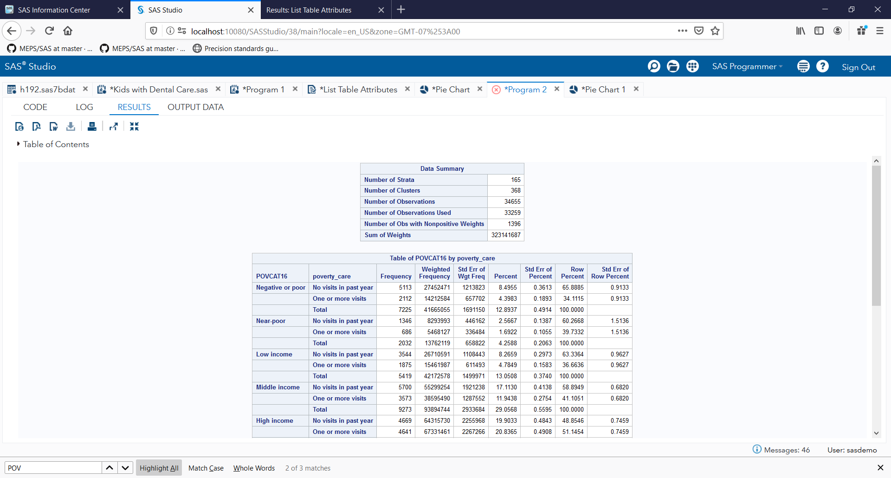

**Figure 2: SAS Code Successfully Running Continued**

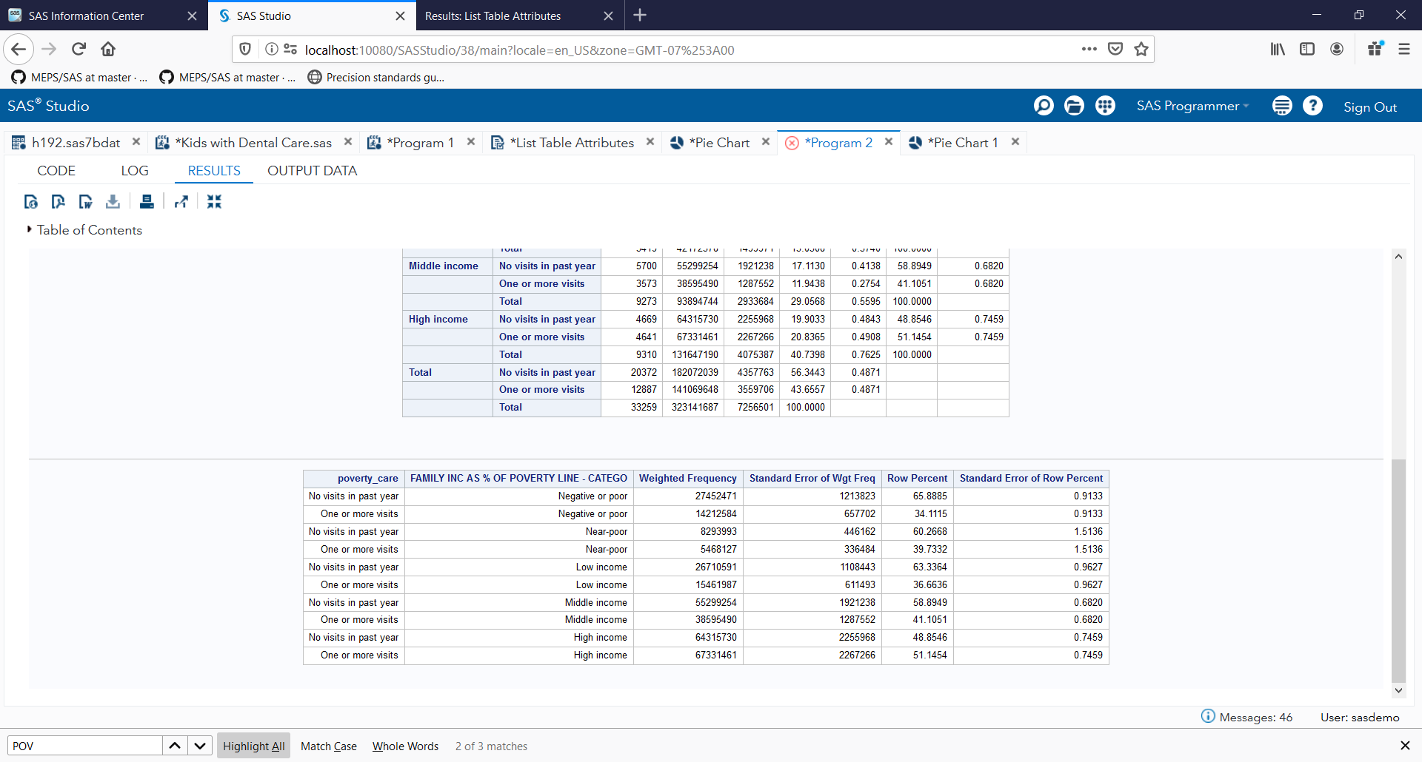

The output tables gave me the total number of respondents who had not visited a medical office for care, or who had visited a medical office for care more than once, separated by poverty levels, and statistically summarized. I copied the output data to Google Sheets for quick visualizations, which produced the bar chart, and pie chart in **Figure 3**. This data did show that poverty levels had a difference in whether or not respondents sought care, but I also noted that the total number of respondents in the poverty categories differed greatly; Negative/Poor were 21.70% of respondents, Near Poor 6.10%, Low Income 16.30%, Middle-Income 27.90%, and high income made up 28% of respondents. Because of this, my bar chart was not the best way to understand if income levels had a difference. To get a better understanding, I adjusted by charts to percentage totals of respondents, by category, in order to produce the stacked bar charts and individual pie charts in **Figure 4**.

These charts displayed the information to prove my alternative hypothesis test in the best way; there is a clear difference in whether or not respondents sought medical care by poverty level, with lower income respondents being least likely to do so. Only 29% of Negative or poor respondents reported seeking medical care more than once, compared to 49% of high income respondents seeking medical care more than once.

It is recognized that income levels have an impact on health because individuals and families in poverty face higher barriers in access to healthcare, as they may be less likely to be insured, and less likely to be able to afford medical services rendered (Khullar, 2018). Lower income individuals may even be less likely to seek out medical care; and this is true of the 2016 Agency for Healthcare Research and Quality's Medical Expenditure Panel Survey (MEPS) data.

**Figure 3: Comparison of Survey Population by Poverty Category**

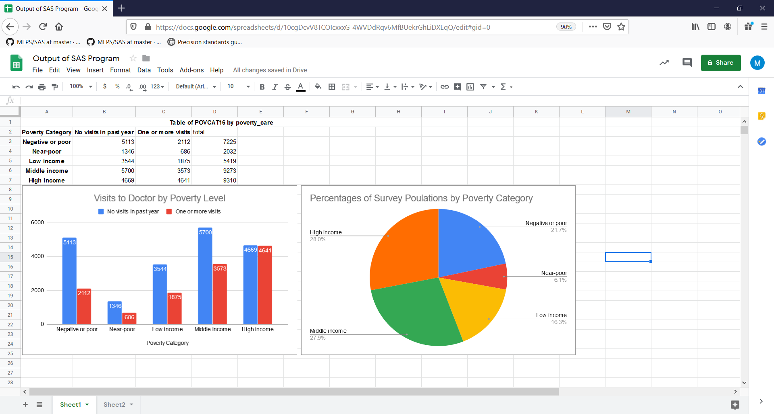

**Figure 4: Google Charts of Visits by Poverty Category- Stacked**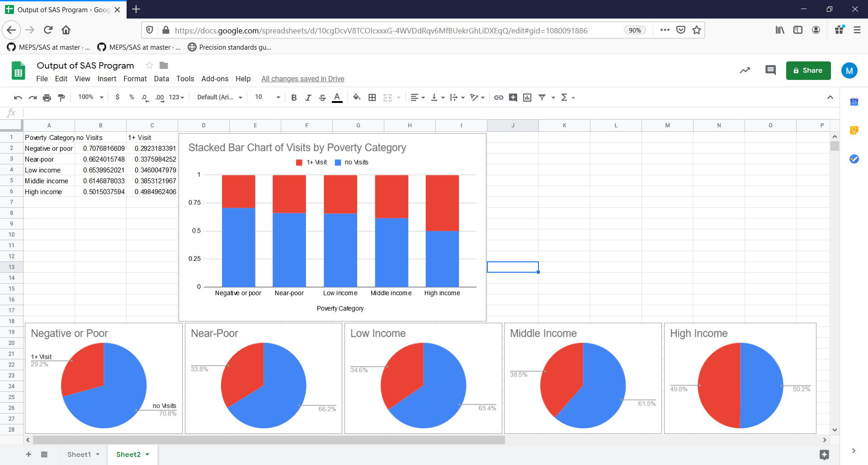

**References**

Healthcare Research. (2019). Survey Background. *Medical Expenditure Panel Survey.* Retrieved from <https://meps.ahrq.gov/mepsweb/about_meps/survey_back.jsp>

Healthcare Research. (2018). MEPS-HC Unweighted Sample Sizes by Policy Relevant Groups for 2016. *Medical Expenditure Panel Survey.* Retrieved from <http://meps.ahrq.gov/mepsweb/survey_comp/hc_sample_policy_group.jsp?year=2016&puf=HC-192>

Mitchell, E. (2019). Care1_child_dental.sas, *GitHub*. Retrieved from

<https://github.com/HHS-AHRQ/MEPS/blob/master/SAS/summary_tables_examples/care1_child_dental.sas>